Owner: Erin Fleming
Schedule: First Proof – June 7th & Final Proof – June 14th
File Type/Format: This will be a microsite built out on Kentico similar to www.tql.com/welcome (the new hire site.) It will not be featured on our webpage but will be sent out individually to candidates who are looking to relocate to Cincinnati.
Background Theme: same as relo templates with the Cincy Skyline. This is not a Fast-Track Branded Piece just Relo. TQL Colors and font.
Microsite will consist of 3 sections:
- Why Cincinnati?
- Areas to Live
- Apartments

WHY CINCINNATI?
- For the why Cincinnati section we want to use what we already have from the “candidate relocation benefits guide”
- Change the “Icon” to “Andrew J. Brady Music Center”
- Add “Jungle Jim’s International Market” as a bullet point under the Eat and drink food section
- We also want to add a picture collage to this page the why Cincinnati Section
  - Trying to decide the best way to layout the imagery- I would like if the first page was image heavy- will need to talk through design with this part

  - 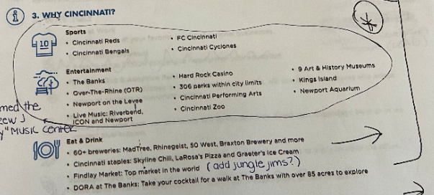

For pictures I think we can pull some from shutter stock and a few we already have from FC stadium.

AREAS TO LIVE
- Eastgate · Beechmont (OH)
  - 10-minute drive or less to HQ
  - 25-minute drive to downtown Cincinnati
  - Low-cost of living
  - Family Friendly
- Amelia · Batavia (OH)
  - 15-minute drive or less to HQ
  - 30-minute drive to downtown Cincinnati
  - Low-cost of living
  - Family Friendly
- Hyde Park · Oakley · Madisonville (OH)
  - 25-minute drive to HQ
  - 10-minute drive or less to downtown Cincinnati
  - Within walking distance to bars, restaurants, and shops
  - Great area for young professionals
- Downtown · OTR (OH)
  - 25-minute drive to HQ
  - Located in the heart of downtown Cincinnati
  - Within walking distance to bars, stadiums, restaurants, nightlife, shops and many other attractions
  - Great area for young professionals
- Newport · Covington (KY)
  - 30-minute drive to HQ
  - 10-minute or less drive to downtown Cincinnati
  - Within walking distance to bars, restaurants, and shops
  - Great area for young professionals
- Blue Ash · Kenwood · Mason · Loveland · Milford (OH)
  - 30-minute drive to HQ
  - 35-minute drive or less to downtown Cincinnati
  - Low-cost of living
  - Family Friendly

Use TQL Icons for the bullet points- Here is how I imagine one would look or something simlar
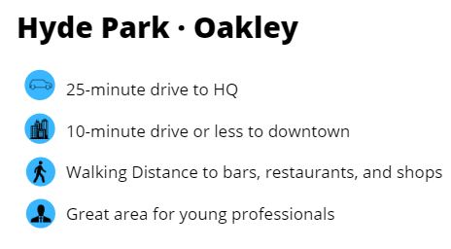

APARTMENTS
- To display apartments, the page will have an interactive map
- When sending back your first draft, just add in one or two apartments from the list at first so we can agree on a look and feel before you do them all
  - Please see excel sheet to reference the information you will need for the apartment
- When you hover over a pin on the apartment’s location it will show
  - The apartments name
  - Contact Phone #
  - And a link to click on that will navigate you to their homepage
- The Map will have a pin that shows where HQ is (this should be bigger or standout in someway than the apartment pins
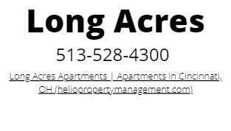
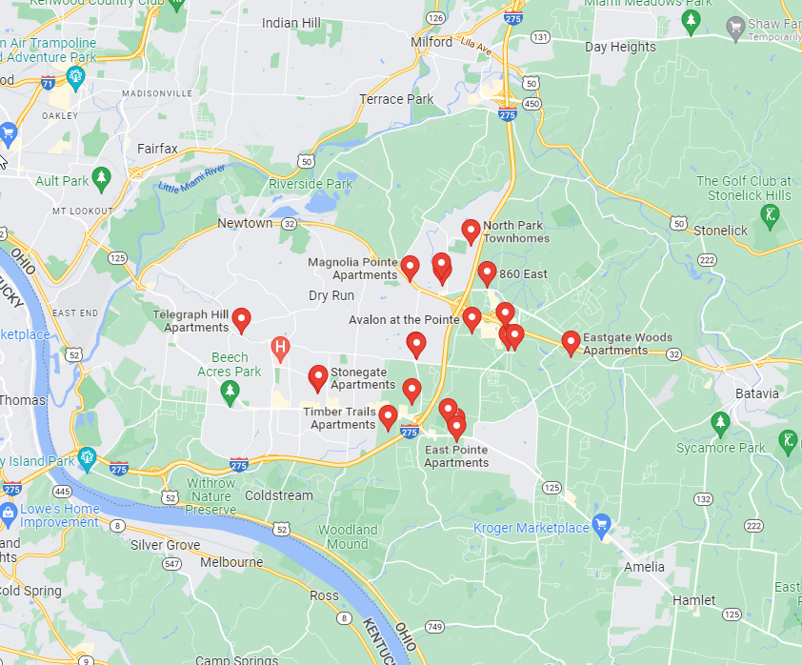

Adding a sentence at the end saying “* This is not an official endorsement from TQL”

